Fourth International Carp Conference

Hotel International

Zagreb, 21 – 22 September 2017.

AGENDA

This Conference is co-financed by the European Union's EMFF fund.

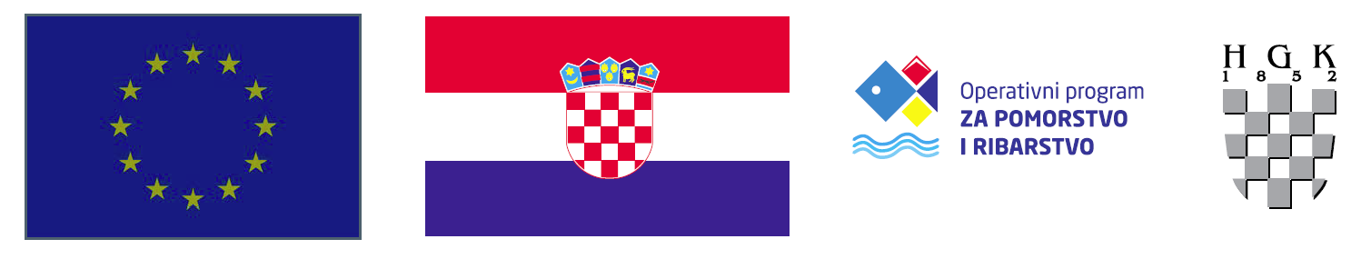
European Union

 | Day 1 |  | 21 September 2017
10.00-12.00 |  | Registration
11.00-12.00 |  | LUNCH BREAK
12.00-13.00 |  | Opening
(13.00-15.00) |  | Working session PRODUCTION AND MARKETING I 2.00 h
13.00-13.20 |  | Production and market, figures, analysis
 |  | Andrzej Lirski
13.20-.13.40 |  | Impact of climate change on the economics of carp farming
 |  | Gergo Gyalog
13.40-14.00 |  | Importance of the Carp ponds for ecosystem and biodiversity preservation – Croatian example
 |  | Ramona Topić, Ana Štrbenac, Vlatka Dumbović Mazal
14.00-14.20 |  | Economical losses caused by cormorants
 |  | Cătălin Eugen Platon
14.20-14.40 |  | New strategic trends in the development of traditional carp production technology
 |  | Urbanyi B., L. Varadi, J. Radoczi, J. Radoczi Jr., A. Hegyi, Gy.Pinter, G. Bernath Z. Bokor
14.40-15.00 |  | Anglers and Carp farmers - mutual benefit partnership
 |  | Ferenc Levai
15.00-15.20 |  | Discussion (all the session's speakers)
15.20-15.50 |  | COFFEE AND NETWORKING BREAK
(15.50 –17.40) |  | Working session PRODUCTION AND MARKETING II 1.50 h
15.50-16.20 |  | EMFF Pond Aquaculture measures in certain EU countries
 |  | Cătălin Eugen Platon, Anna Pyć, speaker from HU
16.20-16.40 |  | Change of consumer habits and market, processing products
 |  | Tomasz Kulikowski
16.40-17.00 |  | Consumer perception of farmed fish in Croatia
 |  | Ekaterina Tribilustova
17.00-17.20 |  | Rearing of carp in combined intensive extensive (CIE) systems: Practical results and experiences.
 |  | Laszlo Varadi
17.20.-17.40 |  | Carp in the FAO program “Aquatic genetic resources for food and agriculture”
 |  | Zigsmond Jeney
17.40-18.00 |  | Discussion (all speakers from previous session)
18.00 |  | End of the first day
20.00 |  | DINNER

 | Day 2 |  | 22 September 2017.
(9.00-10.00) |  | Working session LEGISLATION 1.00 h
9.00-9.20 |  | How carp farmers influence on decision makers
 |  | Anna Pyć
9.20-9.40 |  | Brussels Administration : AAC (Aquaculture Advisory Council) and MAC (Market Advisory Council)
 |  | Bernhard Feneis
9.40-10.00 |  | Aquaculture legislation: too much or not enough?
 |  | Gabriel Popescu
10.00-10.20 |  | Discussion (all speakers from previous session)
10.20-10.30 |  | Book presentation: Fish Nutrition
10.30-11.00 |  | COFFEE AND NETWORKING BREAK
(11.00-12.40) |  | Working session DISEASE 2.20 h
11.00-11.20 |  | Health status of cultured common carp in Croatia
 |  | Emil Gjurčević,
11.20-11.40 |  | Current issues in the Romanian aquaculture diseases and health management
 |  | Iulia Grecu
11.40-12.00 |  | Biosecurity in carp farms in the new European legal framework
 |  | Isabelle Metaxa
12.00-12.20 |  | Hazards for carp farming - KHV disease or actual EU legislation?  A case study of KHV outbreak in the Czech Republic
 |  | Michal Kratochvil
12.20-12.40 |  | Veterinarian aspects, delisting of KHV
 |  | Bernhard Feneis
12.40-13.00 |  | Interplay between cyprinid herpesvirus 3 and common carp body temperature.
 |  | Kris Rakus - University of Krakow
13.00-13.20 |  | Carp edema virus in Germany and differences in susceptibility of common carp strains - results from an epidemiological studies and experimental infections
 |  | Mikolaj Adamek – University of Hannover
13.20-13.40 |  | Discussion (all speakers from previous session)
13.40-14.40 |  | LUNCH BREAK
14.40-14.45 |  | Conference presentation/invitation: 12 years of international scientific and economic conference on aquaculture (freshwater) in Vukovar, Croatia
(14.45-15.50) |  | Working session EU PROJECTS 1.05 h
14.45-15.05 |  | Carp in EU projects
 |  | Laszlo Varadi & Bela Urbanyi
15.05-15.20 |  | Can carp pond culture profit on selective breeding strategy?
 |  | Anna Kristina Sonesson
15.20-15.35 |  | FISHBOOST: results, plans and implications in common carp.
 |  | Martin Kocour
15.35-15.50 |  | Project Aquaexcel
 |  | Vojtěch Kašpar
15.50-16.15 |  | Closing remarks; Presentation of Zagreb Declaration and Resolution
16.15 |  | CONFERENCE END

